**Comprehensive Analysis and Dietary Strategies with Tableau: A College Food Choices Case Study**

**1. INTRODUCTION**

**1.1 Project Overview**

This project analyses college students’ food choices to identify dietary patterns and propose strategies for healthier eating. Leveraging Tableau, the project visualizes insights from a dataset containing information on students’ meals, nutritional intake, and preferences.

**1.2 Purpose**

The purpose is to understand college students’ nutritional habits, highlight potential dietary risks, and suggest improvements through data-driven recommendations and engaging dashboards.

**2. IDEATION PHASE**

**2.1 Problem Statement**

Many college students consume unbalanced diets due to time constraints, lack of awareness, or unavailability of healthy food options on campus. This project aims to analyse students’ food choices and suggest dietary strategies for better nutrition.

**2.2 Empathy Map Canvas**

* Says: “I don’t have time to think about healthy meals.”
* Thinks: “I wish I could eat healthier but it’s too expensive or inconvenient.”
* Does: Skips breakfast, consumes fast food, prefers sugary drinks.
* Feels: Tired, stressed, worried about weight or health.

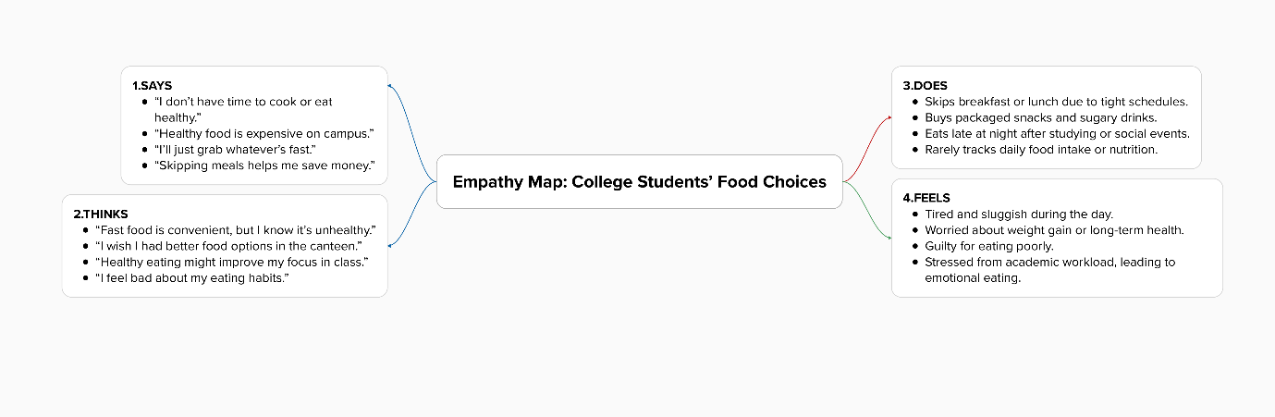

**2.3 Brainstorming**

Ideas generated:

* Collect anonymized food choice data.
* Visualize nutritional intake patterns.
* Correlate health indicators (e.g., GPA, energy levels) with diet.
* Provide easy-to-understand dashboards with actionable insights.

**3. REQUIREMENT ANALYSIS**

**3.1 Customer Journey Map**

|  |  |  |  |
| --- | --- | --- | --- |
| **Phase** | **Action** | **Experience** | **Improvement** |
| Pre-purchase | Choosing meals | Limited healthy choices | Introduce diverse healthy meals |
| Purchase | Buying food on campus | Fast but unhealthy | Healthier grab-and-go options |
| Post-purchase | Eating and performance | Energy crashes | Promote balanced meals |

**3.2 Solution Requirement**

* Collect reliable, anonymized data on college food choices.
* Analyse data to find patterns in unhealthy habits.
* Use Tableau to build dashboards
* Provide recommendations.

**3.3 Data Flow Diagram**

**High-level DFD:**

[Student Food Data] → [Data Cleaning & Preprocessing] → [Data Analysis in Tableau] → [Dashboards & Reports]

**3.4 Technology Stack**

* **Data Cleaning:** Microsoft Excel, Python (optional).
* **Data Analysis & Visualization:** Tableau Public.
* **Documentation & Reporting:** MS Word, PDF.

**4. PROJECT DESIGN**

**4.1 Problem Solution Fit**

The proposed solution aligns with the problem by providing clear visual insights into students’ eating patterns and offering targeted dietary strategies.

**4.2 Proposed Solution**

* Collect data on food choices.
* Clean and preprocess the dataset.
* Visualize calorie intake, macronutrient distribution, and meal frequency.
* Build interactive dashboards.

**4.3 Solution Architecture**

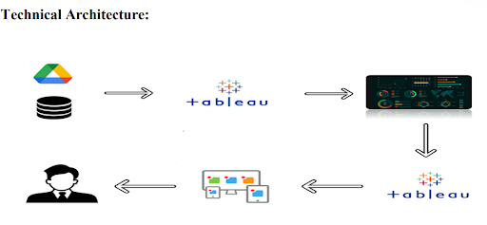

**5. PROJECT PLANNING & SCHEDULING**

**5.1 Project Planning**

* **Week 1-2:** Data collection and preprocessing.
* **Week 3:** Data analysis.
* **Week 4:** Build dashboards.
* **Week 5:** Testing and documentation.
* **Week 6:** Final report submission.

**6. FUNCTIONAL AND PERFORMANCE TESTING**

**6.1 Performance Testing**

* Verified dashboard loading time (<5 seconds on Tableau Public).
* Checked responsiveness across devices (laptop, tablet).
* Confirmed accuracy of visualizations by comparing with sample data calculations.

**7. RESULTS**

**7.1 Output Screenshots**

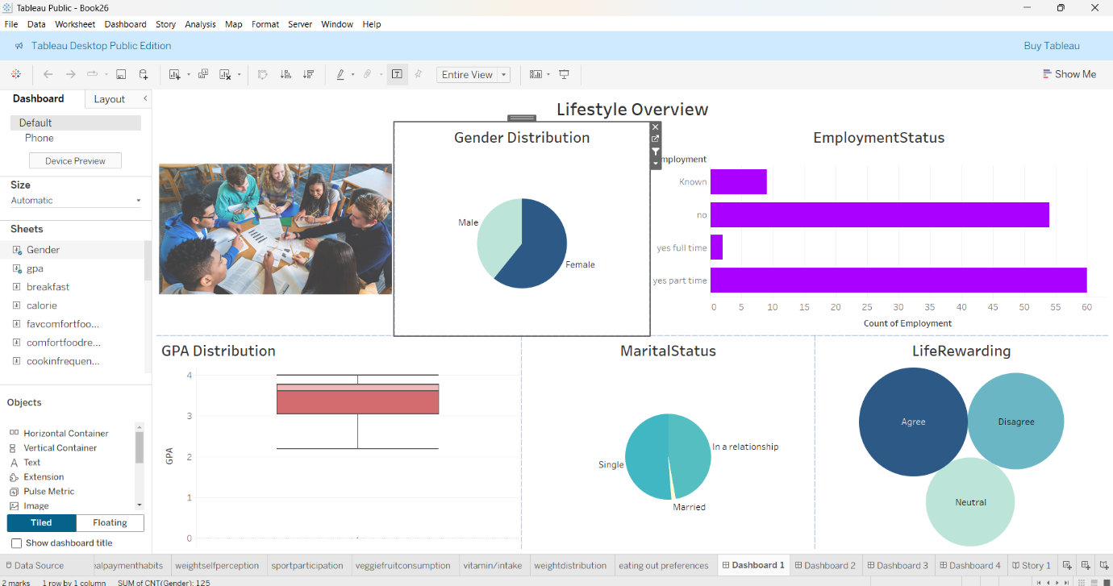

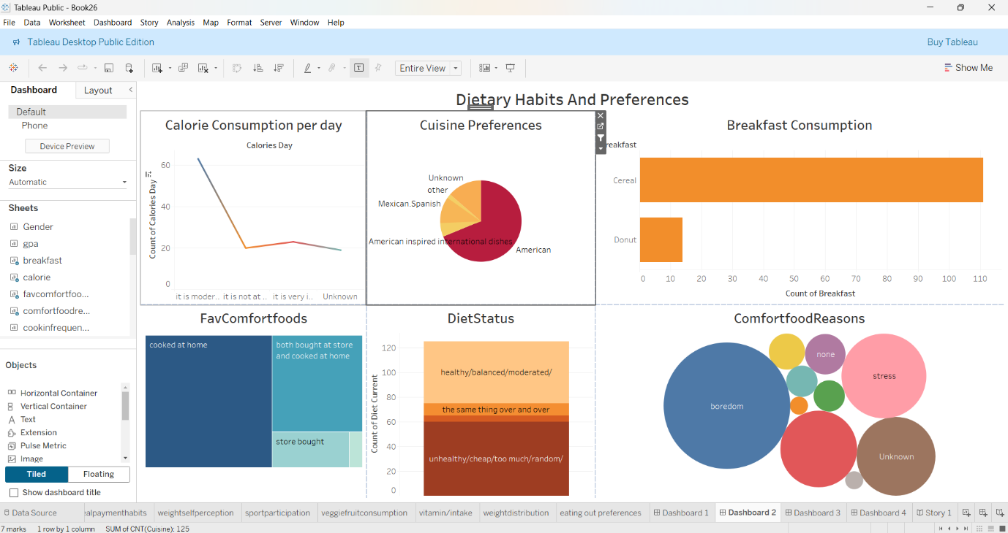

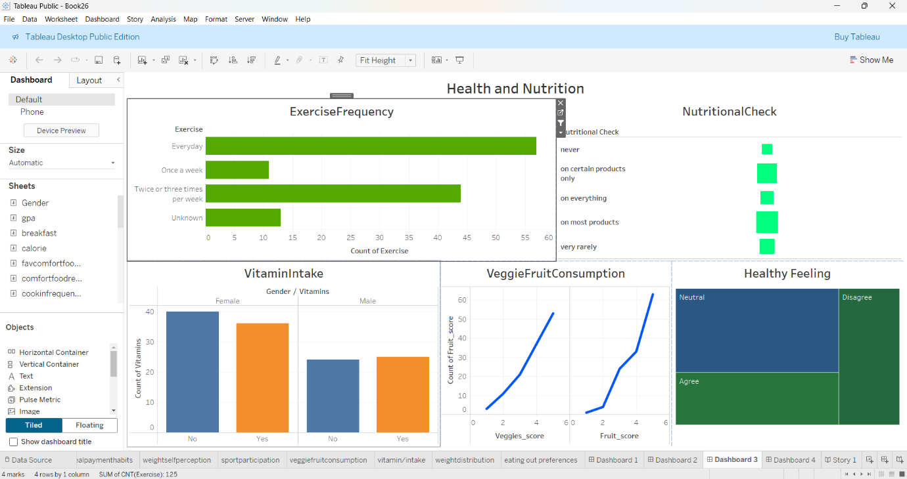

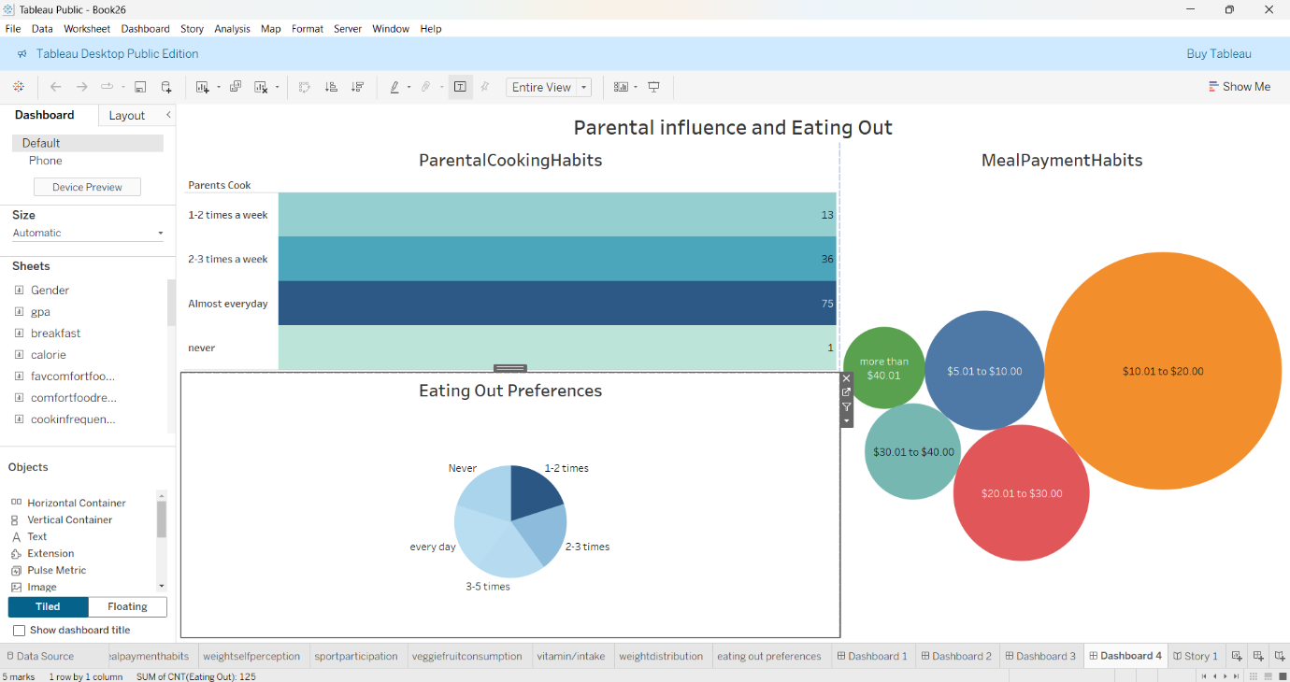

**8. ADVANTAGES & DISADVANTAGES**

**Advantages:**

* Interactive and easy-to-understand dashboards.
* Identifies unhealthy patterns for actionable intervention.
* Supports data-driven decisions for campus dining services.

**Disadvantages:**

* Relies on self-reported data, which may contain biases.
* Limited to one college’s data; generalizability may be low.

**9. CONCLUSION**

This project successfully identified key issues in college students’ dietary habits and proposed strategies to improve nutrition. The Tableau dashboards provide valuable insights to students, college administrations, and food service providers.

**10. FUTURE SCOPE**

* Extend analysis to multiple colleges for broader insights.
* Integrate physical activity data for comprehensive health profiles.
* Develop a mobile app to provide personalized dietary recommendations.

**11. APPENDIX**

* **Dataset Link:** https://www.kaggle.com/datasets/borapajo/food-choices?select=food_coded.csv
* **GitHub & Project Demo Link:** https://github.com/muralikrishna4526/college-food-analysis